Kevin Sekuj

3/8/2022

CS325: Analysis of Algorithms

Homework 9 – NP-Completeness and Heuristic Algorithms

**1. NP-Completeness:**

To prove that Travelling Salesperson is considered to be in NP-Complete, we must prove that the problem is in both NP and in NP-Hard. Thus, we must verify the problem in polynomial time, as well as reduce it by a known NP-Hard problem in order to satisfy both of these constraints, respectively.

1. **Prove that TSP is NP**

TSP seeks to find the path with the minimum cost for visiting each vertex of a graph from a source vertex, and then returning to that source vertex.

We can make a path through the graph and verify that we’ve visited each vertex once. We can sum the edges of the vertices in our path and check if the edge sum is the minimum cost path in the graph, and if so, return it.

This can be verified in polynomial time as we’re only visiting each vertex once.

1. **Prove that TSP is NP-Hard**

Let us use the Hamiltonian Cycle problem, a problem known to be in NP-Hard. A Hamiltonian Cycle is defined as a cycle which passes through all vertices in a graph exactly once.

The TSP problem is defined as finding a cycle for a weighted graph G with a cost of **at most** k, that passes through all the vertices exactly once.

Let us create a graph G = {V, E} to represent a Hamiltonian cycle problem, where V and E are vertices and edges, respectively. Let us give these edges a weight of 0.

Let us form another set of edges, E’, in graph G’ and assign them a weight of 1. We will state that these are the remaining edges from that original graph G.

If we can find a path that crosses all edges with a weight of 0 in Graph G’ exactly once, then we would state that those were the edges originally present in graph G, since the new edges have a weight of 1. Then we have found a Hamiltonian cycle exists in this graph.

In that case, this Hamiltonian cycle we found forms a path with a cost of 0, because we defined all the original graph G’s edges to have a weight of 0. The other edges in the graph G’ which are not part of this cycle have a weight of 1.

Thus, there is a solution for the Traveling Salesman problem in this weighted graph G’ where k <= 0. This can also be done in polynomial time.

We have verified TSP in polynomial time, and reduced Hamiltonian Cycle to TSP. Thus, we have shown that **TSP is NP-Complete**.

2. **Implement Heuristic Algorithm**

a.

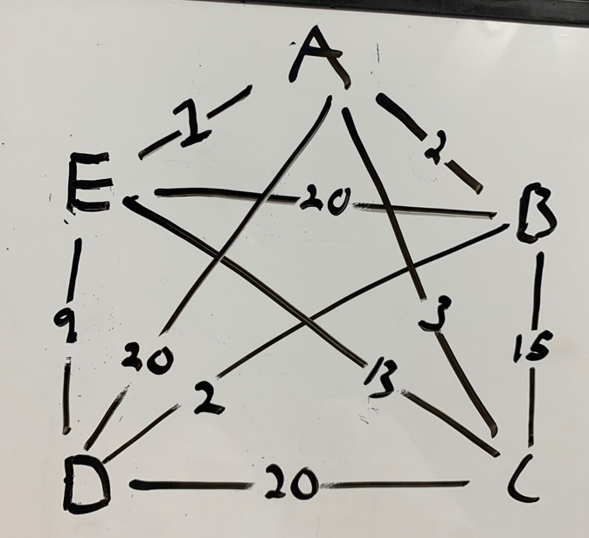

b. **Nearest neighbor heuristic (greedy)**

1.

Visited = {A}

Unvisited = {B, C, D, E, A}  
Cost = 0

2.

Visited = {E}

Unvisited = {B, C, D, A}  
Cost = 1

3.

Visited = {E, D}

Unvisited = {B, C, A}  
Cost = 10

4.

Visited = {E, D, B}

Unvisited = {C, A}  
Cost = 12

5.

Visited = {E, D, B, C}

Unvisited = {A}  
Cost = 27

6. Return to starting point, Node A

Visited = {E, D, B, C, A}

Unvisited = { }  
**Cost = 30**

c. **Approximation ratio**

Greedy approach cost: 30

Optimal approach cost: 29

$p\left(n\right)=\frac{C}{C*}=\frac{30}{29}=1.03 (approx)$

d. **TSP.py**

**References**

* <https://www.csd.uoc.gr/~hy583/papers/ch11.pdf>
* <https://opendsa-server.cs.vt.edu/ODSA/Books/Everything/html/hamiltonianCycle_to_TSP.html>